EXP NO:09 DATE:
Troubleshoot of a Malfunctioning Amplifier Circuit
Aim
To analyze a malfunctioning common emitter amplifier circuit and to identify faults and troubleshoot to restore proper operation.
Apparatus Required
- DC power supply
- Function generator
- Oscilloscope & probes
- 560Ω, 1kΩ, 8.2kΩ, 18kΩ resistors(2) 25uF, 100uF capacitors
- BC147 transistor
- Digital Multimeter (DMM)
- Oscilloscope
- Load Resistor
- Soldering iron and solder
- Spare diodes, resistors, capacitors
Theory
A common emitter amplifier is type of BJT amplifier which increases the voltage level of the applied input signal Vin at output of collector. The CE amplifier typically has a relatively high input resistance (1 - 10 KΩ) and a fairly high output resistance. Therefore it is generally used to drive medium to high resistance loads. It is typically used in applications where a small voltage signal needs to be amplified to a large voltage signal as in radio receivers.
The input signal Vin is applied to base emitter junction of the transistor and amplifier output Vo is taken across collector terminal. Transistor is maintained at the active region by using the resistors R1, R2 and Rc. A very small change in base current produces a much larger change in collector current. The output Vo of the common emitter amplifier is 180 degrees out of phase with the applied the input signal Vin
In this lab, we will be making a common emitter amplifier circuit, and using troubleshooting methods to determine if the circuit is working properly. We will create small problems in the circuit, and observe the results of such errors in the circuit. At the end of this lab,we will have someone create a small error in the circuit, and then troubleshoot the circuit to findthe error. By the end of this lab, we will be able to successfully troubleshoot a common emitter amplifier circuit.
Procedure
Step 1: Visual Inspection
- Check for burnt or broken components.
- Inspect for loose connections or solder joints.
Step 2: Voltage and Current Testing
- Power off the circuit and measure the continuity of the diodes using a multimeter in the "diode" mode.
  - A good diode should show low resistance in one direction and high resistance in the other.
  - A shorted diode will show low resistance in both directions.
  - An open diode will show no conduction in either direction.
- Power on the circuit and measure input and output voltages.
  - Compare with expected values for proper rectifier function.
Step 3: Waveform Analysis Using an Oscilloscope
- Connect the oscilloscope probes across the rectifier output.
- Observe the waveform shape:
  - A working rectifier should show a rectified waveform.
  - An open diode may cause missing pulses.
  - A shorted diode may result in AC leakage.
Step 4: Checking the Filtering Circuit
- If excessive ripple is observed, test the capacitor using a multimeter in capacitance mode.
- Replace faulty capacitors if needed.
Step 5: Troubleshooting & Correction
- Based on the findings, replace defective diodes or capacitors.
- Re-solder loose connections and re-test.
Observations and Results
- Note the measured voltages and compare them with theoretical values.
- Record oscilloscope waveforms and analyze irregularities.
- Identify the root cause of the malfunction.
CIRCUIT DIAGRAM
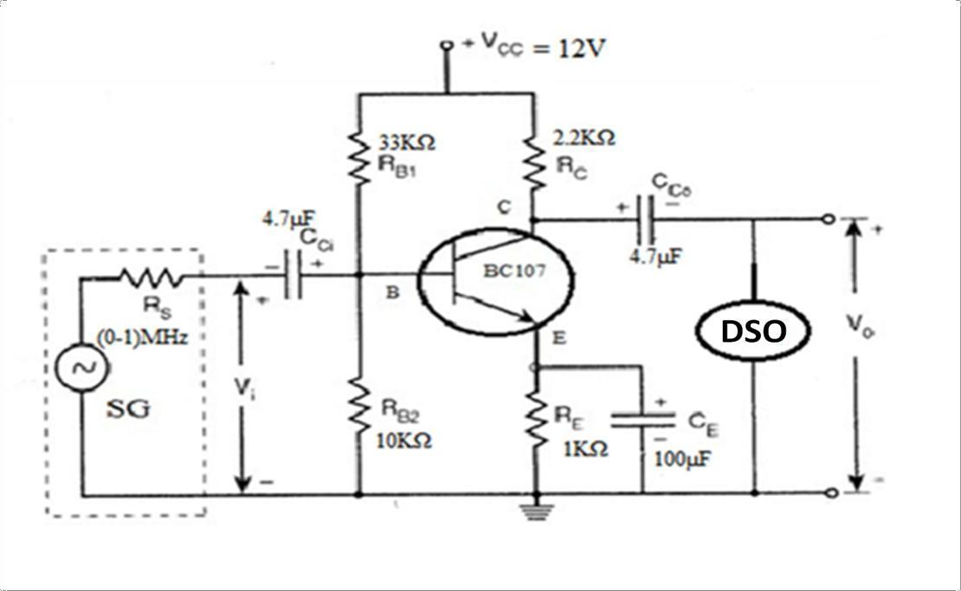
MODEL GRAPH
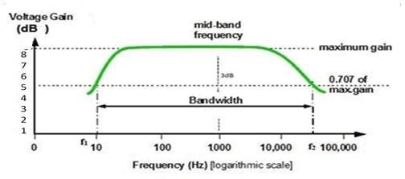
TABULATION : Vin=1V
S.NO | FREQUENCY (HZ) | VO (V) | VO/Vin (V) | GAIN=20log(VO/Vin) (dB)
RESULT:

The Troubleshooting the Common Emitter Amplifier was successfully completed and the following results were observed.
Gain of the amplifier dB
Bandwidth of the amplifier Hz
Gain –Bandwidth Product -------------------------

